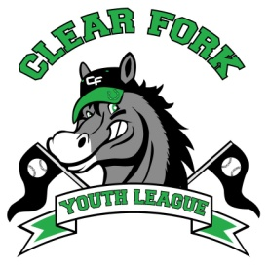
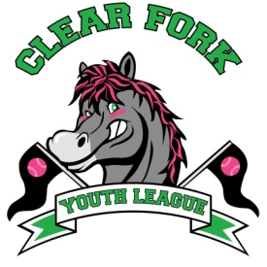
BOARD MEETING
AUGUST 25, 2018
Attendance:
Jay Vail
Mike Hoeflich
Allen Leech
Ashley Ludwig
David Myers
Josh Smith
Carrie Knight

- Voted to file paperwork for 501c3 to be a non profit organization.

- Voted to increase registration fees by $10 for the 2019 season.
  - Baseball and Softball $70
  - Teeball $40

- Discussed adding a fundraiser in the spring.

